

2026 Race Manual

Race Week Updates:

9/11/26
Breaking news.

Not really but here are some updates.

Open Fuel is the nutrition sponsor for Saddles. Their carb/electolyte mix will be at every aid station. We aren’t going to mess with gels quite yet as they require runners to have their own flasks, but this is likely something we will roll out next year at our events.

The Hike Shack will stock Open Fuel if you want to get some or use discount code SADDLES for 25%, here is a direct url https://openfuel.co/discount/SADDLES?redirect=%2Fcollections%2Fall

Im sure most have heard by now but Satisfy has pulled out of Saddles moving forward. This shouldn’t affect you guys at all other than you won’t be able to resell my race shirts on eBay for hundreds of dollars. Or maybe you still can. I know some of you signed up for this race assuming it was the ‘Satisfy’ race. No longer the case. Sorry.

It’s volunteer time! If you have friends/family that want to help out please have them reach out in a separate email thread to saddles100@gmail.com
This years theme is sci-fi/horror/space. Please dress accordingly!
Winners of the Space Division will get some free Nordas. May I suggest the unisex Star Trek mini skirt onesie. It would make me smile if I had a few hundred people running around Prescott in Star Trek drag.

PARKING.
The 50 mile finish, as well as mile 58 at Peavine, and Granite Basin TH are all pay to enter/park. I have had conversations with the city and they will be enforcing this this year. If you do not pay to enter Willow Lake 50 mile finish you will be ticketed. Its $5. Pay it. The Will ow lake pass also works for the Peavine TH. Granite Basin is Forest Service not city so if you want crew access there you will also have to pay the Granite Mountain Access fee. Also $5.

Also at Willow Lake. If you don’t park in an official parking place you will also be ticketed. There is plenty of parking at the other Ramadas and the softballl fields and you can walk over. Along the sides of roads is not acceptable. Ive told you here, I’ll tell you in the manual, I’ll tell you at the runner briefing. Pay the $5 and don’t park like a jackass. (Sorry we’ve just had issues the last couple years with this and the city is getting sick of it).

We are cycling through the waitlist. If you have received an invite you have a couple days to accept or decline or you will be passed on. For those still on the waitlist be patient. Its looking good that you may get picked, we have already gone a lot deeper into than I had initially thought we would.
The 6.66mi fun run on Saturday morning in the dells still has spots. This is a great option for your friends/family/crew to participate and not just sit around waiting for you. Should be fun.
Im sure ill think of more things to say in a couple weeks.

Quick Info

What: 100, 50, 6.66 Mile runs around Prescott

100 mi and 50mi
When: 5:00am OCT 3 (both races)
Where: Fairweather Social Club
Start/Finish 222 N Cortez St Prescott Google Maps

6.66mi
When: 9:00am OCT 3
Where: Willow Lake Hilltop Ramada, 34.61149, -112.44040

Schedule
100 mi and 50mi

Friday: 2:00pm-6:00pm: Packet Pickup at Race Start /Finish
6:00pm: Highly Recommended Course Briefing and Race Meeting
Saturday: 4:00am: Procrastinators Check In
5:00am: Race Start both 100 and 50 Mile
10:00pm: 50 Mile Finish (Willow Lake) Cutoff (17 hours)
Sunday: 3:00pm: 100 Mile Finish (Downtown) Cutoff (34 hours)

6.66mi
Saturday: 8:00am-9:00am: Bib pick up and Check In at Start
9:00am: Race Start
12:00pm: Cutoff
Rules
In short be an adult. Take care of yourself and don’t be a burden on others around you. This is not a road half marathon, where childish behavior is tolerated.

Run the correct course in the allotted amount of time. If you cheat I will know it and you will be banned from ultrarunning.

If you are rude to the staff or volunteers in any way I will pull you from my race zero exceptions. This race is not possible without the volunteers and they are taking days out of there lives to help you run 100 miles to end up in the same place you started. Don’t be a dick.

Outside aid from humans, gas stations, any other source is fine. I actually encourage you to interact with other users of the trail and stop at the gas station in the dells and get a hot dog and an Icee (bring $20)

Dogs: Follow county and City guidelines. Don’t litter. If you drop gear or clothing on the trail expecting a sweeper to pick them up for you, you will be disappointed.

Gear Requirements (6.66 milers exempt)
I hate races with mandatory gear. With that said YOU WILL BE REQUIRED TO CARRY A GPS capable CELL PHONE. In this phone you will have two phone numbers.

Michael Versteeg (Race Director) 9285338191
Mary Buchanan (Medical Director) 9288990585

These phone numbers will also be written on the back of your bib as well as the address for the start/finish line.

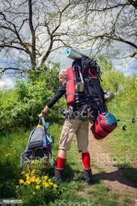
You will also be required to carry a device (watch or phone) capable of downloading and following the GPX of your race. (See course description section for GPX files and directions).
Runner starting UTMB

This is both a safety measure and a practical necessity. Our course follows 100 miles of high use trails around Prescott running through some extremely high use sections (Downtown, Granite Dells, Lynx and Goldwater Lakes, etc) on a Saturday in Prescott in the Fall. These 100 miles are splattered in the middle of over 500 miles of single track trail surrounding Prescott. While the course will be marked well, we are predicting and assuming some sections WILL GET TAMPERED WITH. If you get lost the first thing I will ask you is if you have your watch or phone with the course map on it.

Bring it. No excuses.

The second and last piece is a headlamp. You will not succeed without appropriate lighting. Markers are marked with reflective but only work if they have something to reflect!

Gear Shops
Everything you could possibly need can be found at The Hike Shack in downtown Prescott. Tell them you are a Prescott Area Trail Runner and they will give you a discount. If I find out you went to REI to buy anything while you are here I will ban you from Ultra Running and disqualify you from not just Saddles but from all your other races. They aren’t cheaper, they eat children, they ruin lives.

Minimum Pace Times and Cutoffs
3 miles per hour. Period. See the aid station chart for exact times. THESE TIMES ARE WHEN YOU NEED TO HAVE LEFT THE AID STATION. Zero exceptions, and extremely strict. If you get to the aid station before the cutoff and haven’t left by said time you will be pulled.

Pacers
Pacers are allowed in the 100 mile only starting at mile 50 (Willow Lake). Pacers can stop at any aid and swap.

Shuttles
We will shuttle all 50 mile runners that need it from the 50 mile finish back downtown to the 100 mile finish in crew vehicles.

Parking

There is no weekend regulation of parking in Downtown Prescott on the weekends. You can park anywhere Friday night or Saturday morning and pick up your vehicle by Sunday night or Monday morning.

Dont not leave vehicles at the 50 mile finish Willow Lake. Last year I got in trouble because too many people were parking illegally. If you have to park at the softball fields and walk over then do it.

Zero exceptions to the parking issue. If you park illegally your runner will DQed! (whatever that means)

50 Mile Finish, 6.66 milers And Aid Parking
The 50 mile finish is also the 50 mile Aid Station at the Ramada at Willow Lake. Park only at official parking spots. Along side a road is not an official parking spot. There is limited parking at the boat launch and ramada. There is plenty of extra parking at the softball fields you just have to walk over.

The city will be enforcing this this year so if you dont want a ticket then pay the $5 and find a real parking spot (not the side of a road)

Crew

Crews are only allowed at certain aid stations. See the aid station stuff below..

As a crew member you are an extension of your runner so follow the same rules and be considerate of other users (not limited to race participants). You absolutely can get your runner disqualified with inappropriate behavior.

Aid Stations

There are 11 aid stations. Aravaipa Running is stepping in to make the aid stations legit. We will have a secondary Saddles Aid crew supplementing aid stations with extras. Plus drop bags at every aid station except the first means you are set.

100 Mile

 | Aid Station | Total Mileage | Miles from previous | Crew Access | Drop Bags | Cutoffs (3mph) | Notes
0 | Start Fairweather Space | 0 | 0 | Yes | Yes | 5:00 AM (No Late Starts) | Remember your way out of town so you dont get lost finishing.
1 | Copper Basin | 8.13 | 8.13 | No | No | 8:00 AM | No Crew.
2 | White Rock | 16.5 | 8.37 | Yes | Yes | 10:30 AM | If parking is full find another lot and walk.
3 | Skyline | 23.59 | 7.09 | No | Yes | 1:00 PM | No crew.
4 | Granite Basin Lake | 32.86 | 9.27 | Yes | Yes | 4:00 PM | Paid entry into Granite Mountain Wilderness $5.
5 | Williamson Valley TH | 41.53 | 8.67 | No | Yes | 7:00 PM | No crew.
6 | Willow Lake Ramada (50 Mile Finish) | 50.39 | 8.86 | Yes | Yes | 10:00:00 PM (17 Hours) | Paid access to Willow Lake. Park only in designated spots!!!
7 | Willow Lake Water Only | 53.3 | - | no | no | 11:00 PM | Water Only
 | Peavine TH | 57.8 | 7.4 | Yes | Yes | 12:30 AM | Paid Parking at Peavine TH
8 | Highway 69 | 62.8 | 5 | No | Yes | 2:20 AM | No crew. Longest stretch between aid 11 miles.
9 | Ranch TH (Walker Rd) | 74 | 11.2 | Yes | Yes | 6:00 AM | Limited parking be considerate and do not block access.
11 | Homestead TH | 81.5 | 7.5 | No | Yes | 9:00 AM | No crew
10 | Spruce Mountain | 89.4 | 7.9 | Yes | Yes | 11:45 AM
 | Finish | 100.3 | 10.6 | Yes | Yes | 3:00 PM (34 Hours) | Dont get lost downtown.

50 mile

 | Aid Station | Total Mileage | Miles from previous | Crew Access | Drop Bags | Cutoffs (3mph) | Notes
0 | Start Fairweather Space | 0 | 0 | Yes | Yes | 5:00 AM (No Late Starts) | Remember your way out of town so you dont get lost finishing.
1 | Copper Basin | 8.13 | 8.13 | No | No | 8:00 AM | No Crew.
2 | White Rock | 16.5 | 8.37 | Yes | Yes | 10:30 AM | If parking is full find another lot and walk.
3 | Skyline | 23.59 | 7.09 | No | Yes | 1:00 PM | No crew.
4 | Granite Basin Lake | 32.86 | 9.27 | Yes | Yes | 4:00 PM | Paid entry into Granite Mountain Wilderness $5.
5 | Williamson Valley TH | 41.53 | 8.67 | No | Yes | 7:00 PM | No crew.
6 | Willow Lake Ramada (50 Mile Finish) | 50.39 | 8.86 | Yes | Yes | 10:00:00 PM (17 Hours) | Paid access to Willow Lake. Park only in designated spots!!!

6.66 Mile

 | Aid Station | Total Mileage | Miles from previous | minumum pace | Notes
1 | Willow Lake Ramada (50 Mile Finish) | 0 | 0 | 9:00 AM | Paid access to Willow Lake. Park only in designated spots!!!
2 | Willow Lake Water Only | 3 | 3 | 10:30 AM | Water Only
3 | Willow Lake Ramada (50 Mile Finish) | 6.66 | 3.66 | 12:00 PM | Paid access to Willow Lake. Park only in designated spots!!!

Drop Bags

As noted in the Aid Station section, we are allowing drop bags at every official aid station except Copper Basin so plan your race however you wish. The relatively easy access to aid stations allows us to offer this. Drop bags can be dropped off on Friday at bib pick up or on saturday morning before the race at the start line. All drop bags will be returned to the start finish by Sunday afternoon. We will not be mailing out left dropped bags so if you leave it you will never see it again.

Medical and Emergencies

Non emergency situations please call the numbers you have saved in your phone and on the back of your bibs. Shit happens, I get it. Do not call 911 if you need to drop in between aid stations or aren’t feeling good. 99% of the time situations can be resolved without involving the feds.

In the case of a life threatening or dangerous emergency, call 911 and the numbers on your bib and inform the race what is going on.

Weather

Expect highs in the mid 70s and lows in the 40s.. This is Fall in Northern Arizona so don’t trust in averages too much. It can snow and be 85 in the same day. In short, be prepared for it all!

Last year was insanely hot. The year before that everyone got hailed on. Be prepared.

Course Marking

The entire course will be marked with pink flags with reflective tape for night time running. Junctions will also have arrow and wrong way signs when necessary. As stated earlier, we are anticipating some course tampering due to the high use nature of many of these trails. Bring your phone, have the route enabled with a gps device. I have been the course marker at Zion, Antelope, and Bryce 100 for many years so for those of you who have run one of those it will be the same. For those of you who haven’t anticipate dreaming of pink ribbons for days after the race.

Course Maps, GPX, and Descriptions

Quicklinks to GPS and Online Maps
100 mile https://caltopo.com/m/PPAV1L7
50 mile https://caltopo.com/m/M6QBLNN
6.66 mile https://caltopo.com/m/C3TN12H

100 Mile
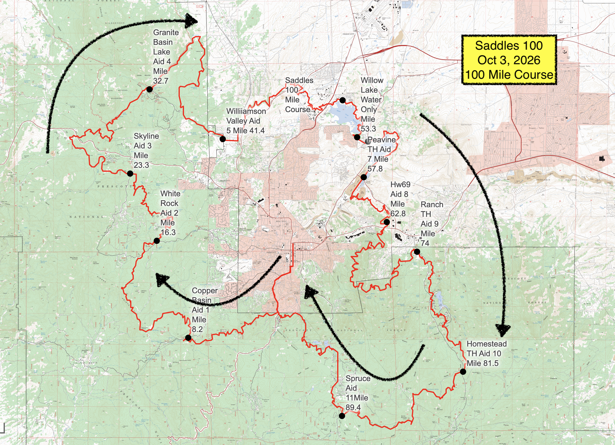

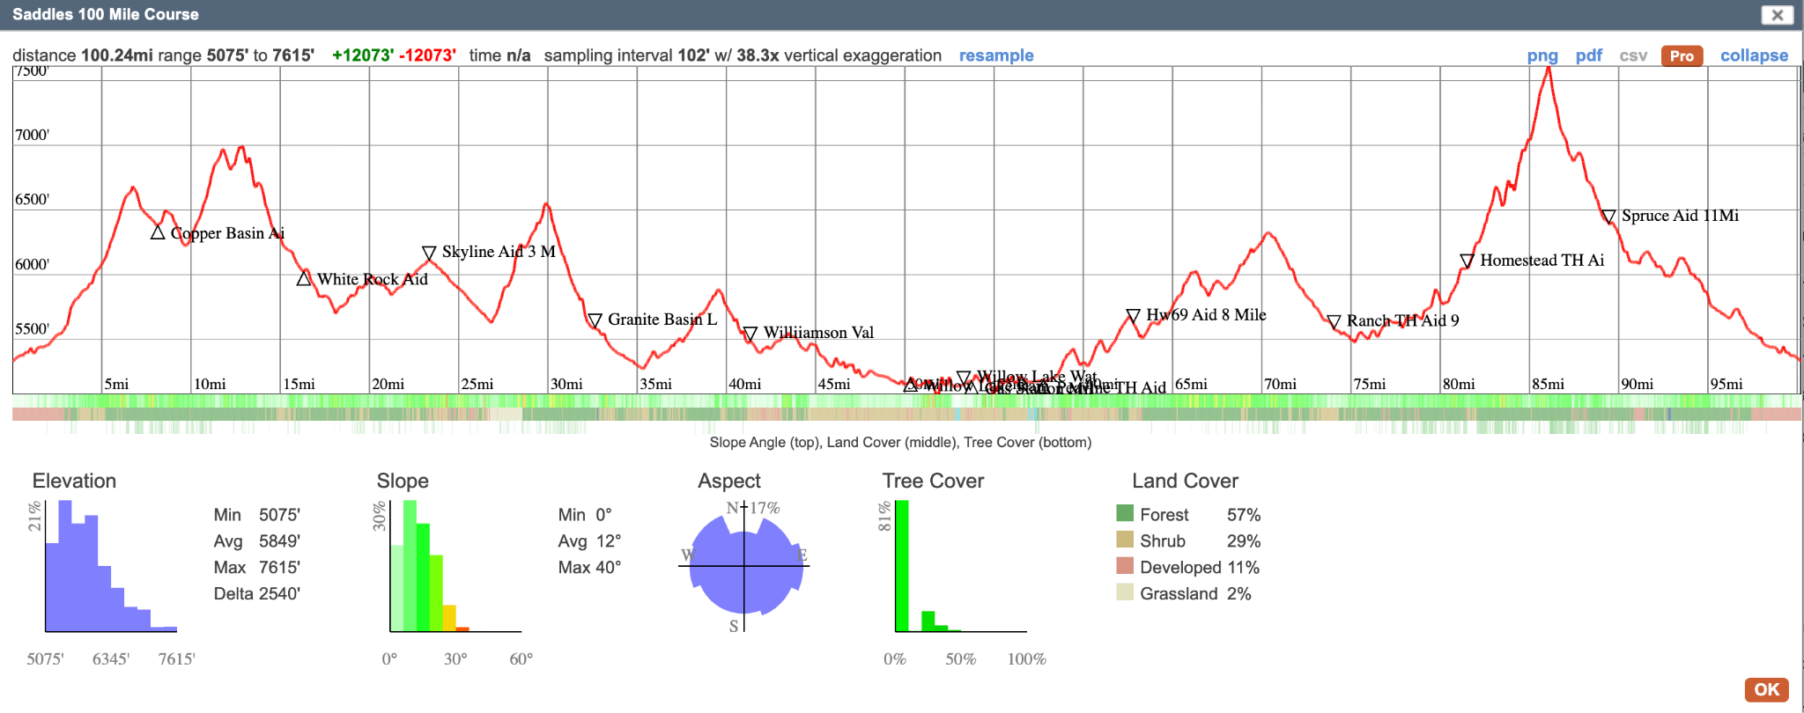

Elevation Gain +12,064’

Caltopo Links:

Full GPX Route for Downloading to watch and Phone

https://caltopo.com/m/PPAV1L7

Download Directions (Desktop)
1. Click export under map objects
2. Select GPX under format.
3. Download.
4. Open Gaia or other GPS app
5. Import route from Download folder.

Cell Phone
- Click folder icon in upper left toolbar (below the ruler)
- Click export
- Select GPX under format
- Download
- Same as above

50 Mile
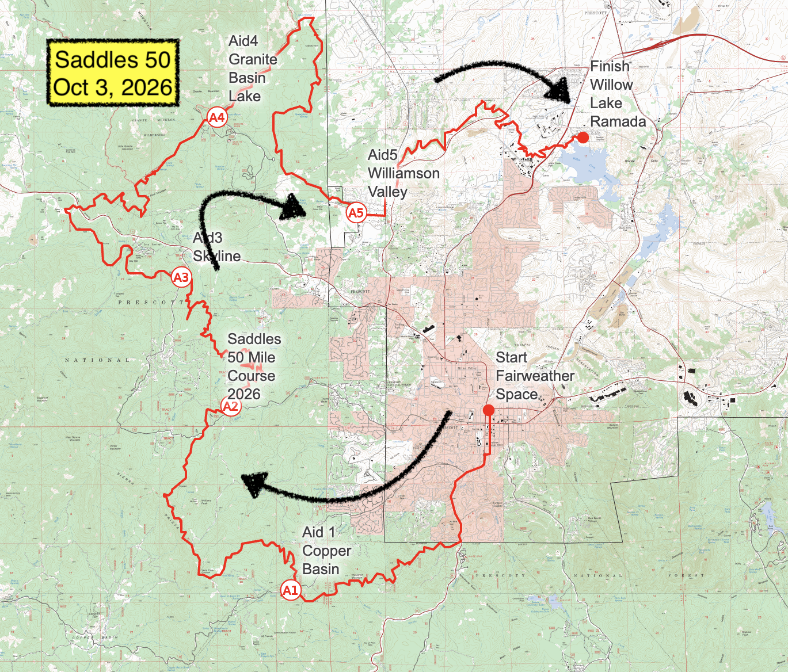

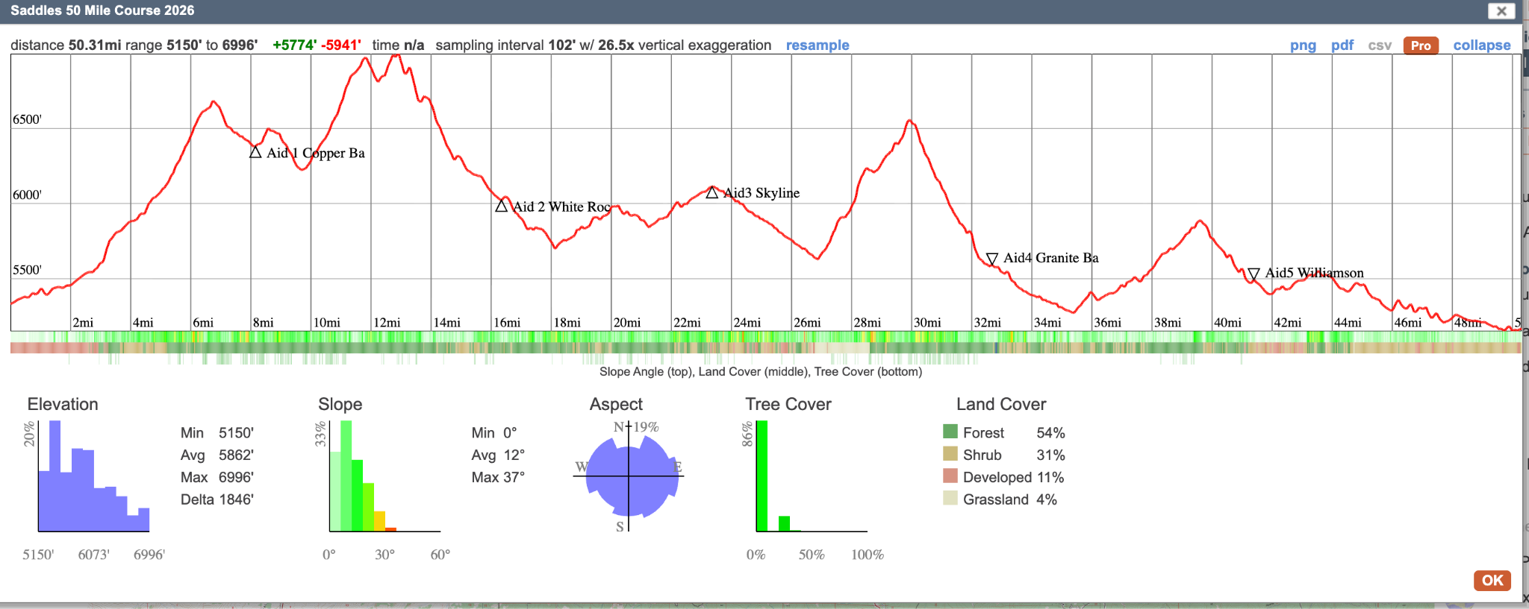

Full GPX Route for Downloading to watch and Phone

https://caltopo.com/m/M6QBLNN

See download instructions in 100 mile section

Elevation Gain +6,125’

6.66 mi

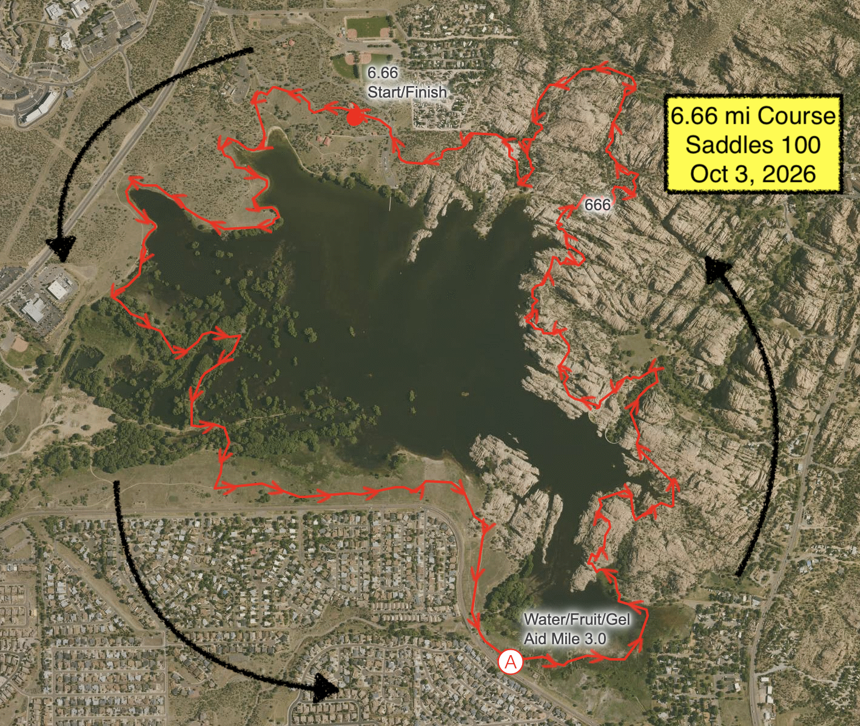

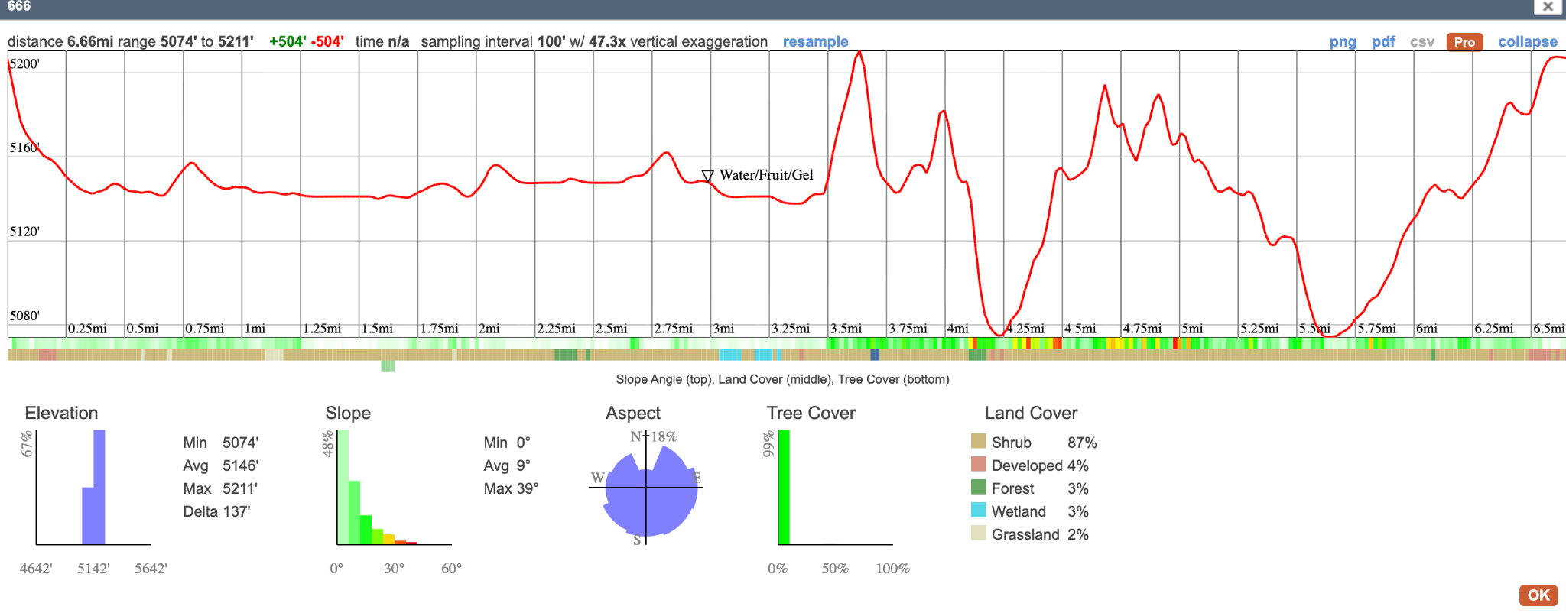

Elevation Gain 500’
Caltopo Links:

Full GPX Route for Downloading to watch and Phone

https://caltopo.com/m/C3TN12H

Download Directions (Desktop)
1. Click export under map objects
2. Select GPX under format.
3. Download.
4. Open Gaia or other GPS app
5. Import route from Download folder.

Cell Phone
- Click folder icon in upper left toolbar (below the ruler)
- Click export
- Select GPX under format
- Download
- Same as above

A Final Note
This race has been a dream of mine for about a decade. What I have done is created a race that I would want to run. Not direct. For those looking for a Western States or UTMB experience, this will never be that. I am not here to sell you a product but to bring you in for an experience. This is a shit kicking , gun shooting, toilet paper finish line, grassroots trail run that you will need to be capable and self reliant to complete. Don’t die. Be nice. Listen to Black Sabbath.




